(Approximately 1161 words)

Potpourri of Tips
August Meeting Review: Golden Gate Computer Society
September 2017 issue, GGCS Newsletter
www.ggcs.org
editor (at) ggcs.org

Steve Shank led off the panel of GGCS gurus tip-talking during the August 28 General Meeting. Other panelists included Marcelino Nogueiro, James Gafford, and Barbara Hansen.

Password Manager
Steve says, LastPass offers a free version and, for $24/year/person, a premium version. The two versions are identical when used on computers. The difference is that only the premium version can also be used on mobile devices. In both cases, LastPass offers unlimited password storage and syncing across multiple devices that have LastPass installed, and two-factor authentication. It operates as a browser extension, with support for all major browsers and operating systems.

LastPass Premium adds enhanced password sharing options, storage of desktop-app passwords and support for physical authentication devices. LastPass automatically captures all passwords as you enter them into a website. All passwords are encrypted with your master password before they are stored in the Cloud and are encrypted on your hard drive.

You must create a strong Master Password, which ensures that nobody, even at LastPass, has access to your data.

This password must comprise at least 12 characters, including at least one digit, and a mix of capital and lowercase letters.

Multi-factor authentication requires that, when you log in, you will need a onetime code
generated by the app, as well as your Master Password.

Dashland and Roboform are prominent among many other password managers.

Marcelino then offered a house-generated password option where the main part of the password would have at least eight characters, including numbers, upper and lowercase letters and punctuation. Then, for each site, you would add, say, two more characters, to distinguish that site from others. He recommends a minimum overall total of 12 characters.

Snipping tool
Marcelino, assisted by James, explained that the useful Snipping Tool is a free screenshot utility and demonstrated that it permits screen shots of full screen, rectangular areas, or free-form areas using a mouse or a tablet. The image can be saved as JPEG, GIF, or PNG, it can be copied and pasted, and it can be emailed.

Colored pens, eraser, and highlighter allow annotating the image (You cannot make direct changes to the snipped image. An image editing program would have to be used for any edits). It also has a Delay function that allows for timed capture of screenshots.

Link shorteners
Steve demonstrated a link shortener, in this case www.bit.ly by pasting a long web link URL into its webpage and the page generated a shortened version in the format www.bit.ly/xxxxx. When the shortened link is clicked, the user is redirected to the full web link.

For example, you could shorten a 500-character, three-line link to say 12 characters. Bit.ly will shorten any link given to it even if you don’t have an account.

However, with an account (free), you can have some degree of customization of the shortened result. (It also offers an enterprise version with more customization.) The shortened link is then owned by you and cannot be changed by others.

System tray
The system tray at the bottom right side of the computer screen and the icons in the tray are for programs that run all or part of the time and show current status of systems, Marcelino said. Some icons may be hidden, but can be selected by left clicking the up-facing arrow and dragged onto the bar, if required.

The system tray shows the date and time as well as the status of the various icons in the tray. At the extreme right side is the Notification icon which, when clicked, shows an Action center, and with a left-click, the status of all your Windows settings, and network and internet settings.

Right-clicking an icon, such as the Speaker icon, gives choices as to how to make changes. Marcelino suggested it would be a good idea to have Windows Defender on the system tray. Marcelino also recommend adding the Snipping tool to the Taskbar. Note that the Taskbar is the set of icons to the right of the Start button and to the left of the System tray.

Alexa
Alexa Dot and its big sibling, Echo, are well-known personal assistants, Marcelino said, and now have a multitude of voice-activated capabilities, including playing music, playing radio, giving reminders, setting timers, setting lamps, telling jokes, giving weather reports, etc.; additional control of lamps and other electrical systems are available by using modules like the Insteon Hub. Both the Echo and Dot can interface with home automation systems enabling voice activated commands. It acts as a hub for other Dot or Echo units in the house.

Barbara Hansen has the (free) Alexa app on her iPhone and uses it to ask Alexa for the current time and for news briefings from, say, the BBC, WSJ, NPR, The Economist, etc.

Barbara also uses Alexa to add to her calendar, and to advise her of calendar activities and their date/time. She also asks Alexa to read to her from a Kindle book.

Amazon Echo/Alexa can be set up to control lights and appliances around your home using an Insteon Hub controller and corresponding control switches, as was done at the meeting, and explained by Marcelino (see diagram, Fig. 1).
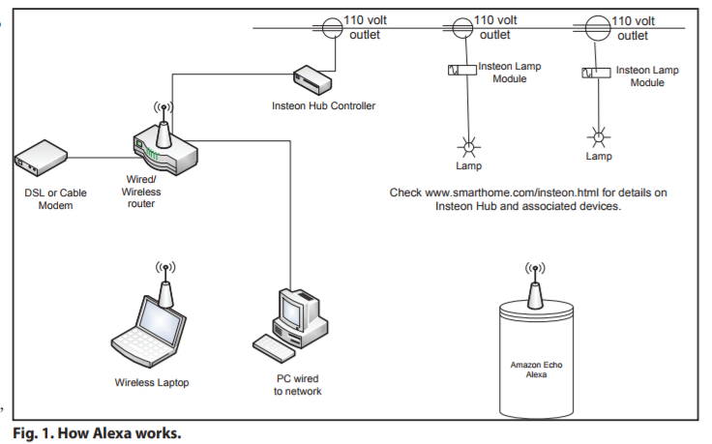

Additional information can be found at https://www.smarthome.com/insteon.html. Microsoft’s Cortana, and Google’s Home offer similar services.

Google Forms
Steve demonstrated how, with Google Forms, he created a survey voting form for members of his wine club to register their individual scores for various wines that had been tasted at a meeting.

Once the form has been created, the link is sent to others. Google Forms has a simple user interface and powerful editor, and works together with Google Sheets spreadsheets. Results can be listed or presented automatically as a graph. It is an easy-to-use form builder with a spreadsheet backend, with only nine question types and basic color plus photo themes, and it can be customized. Google Forms is free with a Google account, but you don’t need a Google account to respond to Google Forms.

MS Word with pictures
James showed us how to construct an annotated album in MS Word, using photos from his wedding and honeymoon in Scotland, last year. His first step was to create a blank page with a texture and color; and a watermark. Then James added all the text associated with the wedding.

His next step was to select a picture, which, once in Word, will have a boundary that permits resizing the picture to the required size. The picture is then treated like a character in the text and can then be inserted, by positioning it with its associated
“anchor,” at the start of a paragraph. James next added captions to the pictures.

As a final step, James added some graphic art to pictures, using images.google.com and saving as a transparent PNG file, which was then “floated” into position in the picture.

